Observing Cloud Resources

*SRE Assessment Template*

# Categorize Responsibilities

|  |  |
| --- | --- |
| **Prometheus and Grafana Screenshots** | |
| Provide a screenshot of the Prometheus node_exporter service running on the EC2 instance. Use the following command to show that the system is running: sudo systemctl status node_exporter | |
|  | |
| **Host Metric**  **(CPU, RAM, Disk, Network)** | **Dashboard** |
| *CPU* |  |
| *Memory Total* |  |
| *Disk I/O* |  |
| *Network transmit* |  |
| **Responsibilities** | |
| 1. The development team wants to release an emergency hotfix to production. Identify two roles of the SRE team who would be involved in this and why. | |
| *Release Engineer and Monitoring Engineer. Because Release Engineer will manage the release and Monitoring Engineer will monitor the new hotfix will run well in production* | |
| 2. The development team is in the early stages of planning to build a new product. Identify two roles of the SRE team that should be invited to the meeting and why. | |
| *System Architect and Infrastructure Engineer. Because System architects have a knowledge about the architecture so they will provide solutions faster and Infrastructure will know infrastructure that will map with the new feature* | |
| 3. The emergency hotfix from question 1 was applied and is causing major issues in production. Which SRE role would primarily be involved in mitigating these issues? | |
| *Release Engineers will be better, because their responsibility of them is to manage release, so they will know about the issue will come from exact role* | |

# 

# Team Formation and Workflow Identification

|  |
| --- |
| **API Monitoring and Notifications** |
| Display the status of an API endpoint: Provide a screenshot of the Grafana dashboard that will show at which point the API is unhealthy (non-200 HTTP code), and when it becomes healthy again (200 HTTP code). |
|  |
| Create a notification channel: Provide a screenshot of the Grafana notification which shows the summary of the issue and when it occurred. |
|  |
| Configure alert rules: Provide a screenshot of the alert rules list in Grafana. |
|  |

# 

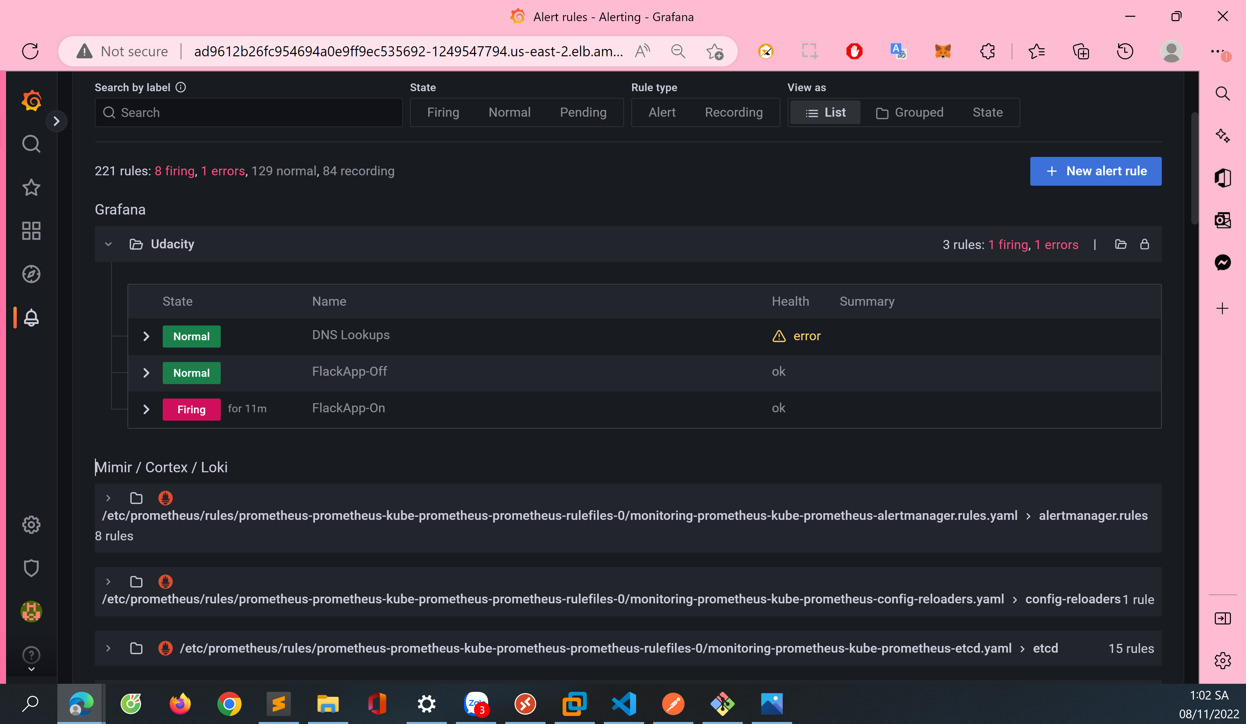

# Applying the Concepts

|  |
| --- |
| **API Heathcheck** |
|  |
| 4a. Given the above graph, where does it show that the API endpoint is down? Where on the graph does this show that the API is healthy again? |
| *API endpoint is down at 15:27 and it healthy again at 15:36* |
| 4b. If there was no SRE team, how would this outage affect customers? |
| *The API endpoint of customers will not be known and maybe the downtime will be more than the metrics* |
| 4c. What could be put in place so that the SRE team could know of the outage before the customer does? |
| There will be an alerts (can be sms, mail or call) for SRE team know before the customer does |

|  |
| --- |
| **Network Received** |
|  |
| 5a. Given the above graph, which instance had the increase in traffic, and approximately how many bytes did it receive (feel free to round)? |
| *10.0.0.68:9100 had the increase in traffic, the latest in graph that it receive about 4900 bytes* |
| 5b. Which team members on the SRE team would be interested in this graph and why? |
| *Monitoring Engineer would be intersted in this graph, because in this role, they will need to monitoring* |

# 

# 